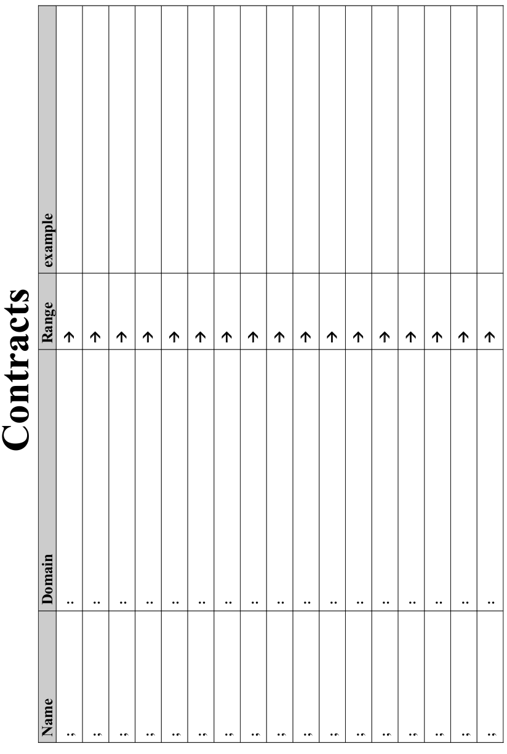

Lesson 1

Reverse-Engineering: How does NinjaCat work?

Thing in the game… | What changes about it? | More specifically...
cloud | position | x-coordinate

Game Parts - NinjaCat!
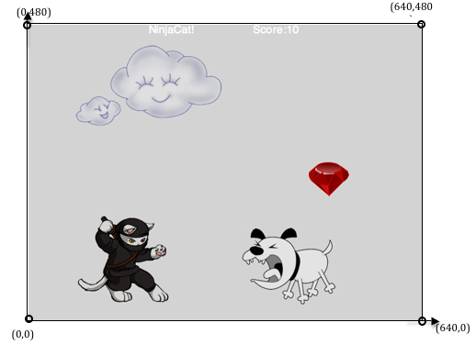

The coordinates for the PLAYER (NinjaCat) are: ( , )
x-coordinate y-coordinate

The coordinates for the DANGER (Dog) are: ( , )

The coordinates for the TARGET (Ruby) are: ( , )

Our Videogame

Created by (write your names): ____________________________________________________

Background

Our game takes place: ________________________________________________________
(In space? The desert? A mall?)

The Player

The player is a _____________________________________.
The player moves only up and down.

The Target
Your player GAINS points when they hit the target.
The Target is a _____________________________________.
The Target moves only to the left and right.

The Danger
Your player LOSES points when they hit the danger.
The Danger is a ____________________________________.
The Danger moves only to the left and right.
Circle of Evaluation Practice! Time: 5 minutes
Don't forget to use the computer's symbols for things like multiply and divide!

Math | Circle of Evaluation | Racket Code
5 x 10
8 + (5 x 10)
(8 + 2) - (5 x 10)
5 x 10
8 - 2

Lesson 2
(draw Circles of Evaluation here if you need extra scratch paper)

Circles Triathalon Time: 5 minutes
 | Math | Circle of Evaluation | Racket Code
Round 1 | (3 * 7) - (1 + 2)
Round 2 | 3 - (1 + 2)
Round 3 | 3 - (1 + (5 * 6))
Round 4 | (1 + (5 * 6)) - 3

Lesson 3


Fast Functions!
Fill out two examples for each function, then try to write the contract, examples and definition by yourself.
; _________________:_________________ -> ________________
name domain range
(EXAMPLE (______ ________) _____________________________)
(EXAMPLE (______ ________) _____________________________)
(define (________ _______) ____________________________)

; _________________:_________________ -> ________________
name domain range
(EXAMPLE (______ ________) _____________________________)
(EXAMPLE (______ ________) _____________________________)
(define (________ _______) ____________________________)

; _________________:_________________ -> ________________
(EXAMPLE (______ ________) _____________________________)
(EXAMPLE (______ ________) _____________________________)
(define (________ _______) ____________________________)

; _________________:_________________ -> ________________
(EXAMPLE (_______ _______) _____________________________)
(EXAMPLE (_______ _______) _____________________________)
(define (________ _______) ____________________________)

Fast Functions!
Fill out two examples for each function, then try to write the contract, examples, and definition by yourself.
; _________________:_________________ -> ________________
name domain range
(EXAMPLE (______ ________) _____________________________)
(EXAMPLE (______ ________) _____________________________)
(define (________ _______) ____________________________)

; _________________:_________________ -> ________________
name domain range
(EXAMPLE (______ ________) _____________________________)
(EXAMPLE (______ ________) _____________________________)
(define (________ _______) ____________________________)

; _________________:_________________ -> ________________
(EXAMPLE (______ ________) _____________________________)
(EXAMPLE (______ ________) _____________________________)
(define (________ _______) ____________________________)

; _________________:_________________ -> ________________
(EXAMPLE (______ ________) _____________________________)
(EXAMPLE (______ ________) _____________________________)
(define (________ _______) ____________________________)

Lesson 4

Design Recipe

Word Problem: rocket-height
A rocket blasts off, traveling at 7 meters per second. Write a function called “rocket-height” that takes in the number of seconds that have passed since the rocket took off, and which produces the height of the rocket at that time.

Contract+Purpose Statement
Every contract has three parts:

; __________________ : _________________________________________ -> ______________
name Domain Range

; _______________________________________________________________________________
What does the function do?

Give Examples
On the computer, write an example of your function in action, using EXAMPLE.

(EXAMPLE (___________________________________________)
the user types…

_________________________________________________)
..…which should become

(EXAMPLE (___________________________________________)
the user types…

_________________________________________________)
..…which should become

Definition
Write the definition, giving variable names to all your input values.

(define (____________ ___________________)
function name variable names

________________________________________________)
..…and the computer does this

Design Recipe

Word Problem: red-square
Use the Design Recipe to write a function red-square, which takes in a number (the size of the square) and outputs a solid red rectangle whose length and width are the same size.

Contract+Purpose Statement
Every contract has three parts:

; __________________ : _________________________________________ -> ______________
Name Domain Range

; _______________________________________________________________________________
What does the function do?

Give Examples
On the computer, write an example of your function in action, using EXAMPLE

(EXAMPLE (___________________________________________)
the user says…

_________________________________________________)
..…Racket replies

(EXAMPLE (___________________________________________)
the user says…

_________________________________________________)
..…Racket turns that into

Definition
Write the definition, giving variable names to all your input values.

(define (____________ ___________________)
function name variable names

________________________________________________)
..…and the computer does this

Design Recipe

Word Problem: yard-area
Use the Design Recipe to write a function yard-area, which takes in the width and length of a yard, and returns the area of the yard.
(Don’t forget: area = length * width !)

Contract+Purpose Statement
Every contract has three parts:

; __________________ : _________________________________________ -> ______________
name Domain Range

; _______________________________________________________________________________
What does the function do?

Give Examples
On the computer, write an example of your function in action, using EXAMPLE.

(EXAMPLE (___________________________________________)
Use the function here

_________________________________________________)
find another way to get the same result here

(EXAMPLE (___________________________________________)
Use the function here…

_________________________________________________)
find another way to get the same result here

Definition
Write the definition, giving variable names to all your input values.

(define (____________ ___________________)
function name variable names

________________________________________________)
..…and the computer does this

Lesson 5

Design Recipe

Word Problem: update-danger
Use the Design Recipe to write a function update-danger, which takes in the danger's x-coordinate and produces the next x-coordinate, which is 50 pixels to the left.

Contract+Purpose Statement
Every contract has three parts:

; __________________ : _________________________________________ -> ______________
name Domain Range

; _______________________________________________________________________________
What does the function do?

Give Examples
On the computer, write an example of your function in action, using EXAMPLE.

(EXAMPLE (___________________________________________)
Use the function here

_________________________________________________)
find another way to get the same result here

(EXAMPLE (___________________________________________)
Use the function here…

_________________________________________________)
find another way to get the same result here

Definition
Write the definition, giving variable names to all your input values.

(define (____________ ___________________)
function name variable names

________________________________________________)
..…and the computer does this

Design Recipe: update-target

Word Problem: update-target

Write a function update-target, which takes in the target's x-coordinate and produces the next x-coordinate, which is 50 pixels to the right.

Contract+Purpose Statement
Every contract has three parts:

; __________________ : _________________________________________ -> ______________
name Domain Range

; _______________________________________________________________________________
What does the function do?

Give Examples
On the computer, write an example of your function in action, using EXAMPLE.

(EXAMPLE (___________________________________________)
Use the function here

_________________________________________________)
find another way to get the same result here

(EXAMPLE (___________________________________________)
Use the function here…

_________________________________________________)
find another way to get the same result here

Definition
Write the definition, giving variable names to all your input values.

(define (____________ ___________________)
function name variable names

________________________________________________)
..…and the computer does this

Lesson 6

Protecting Sam

Sam is in a 640 x 480 yard. How far he can go to the left and right before he's out of sight?

- A piece of Sam is still visible on the left as long as... (> x -50)

- A piece of Sam is still visible on the right as long as... ___________________

- Draw the Circle of Evaluation for these two expressions in the circles below:

Design Recipe

Word Problem: safe-left?

Use the Design Recipe to write a function safe-left?, which takes in the target's x-coordinate and checks to see if it is greater than -50.

Contract+Purpose Statement
Every contract has three parts:

; __________________ : _________________________________________ -> ______________
name Domain Range

; _______________________________________________________________________________
What does the function do?

Give Examples
On the computer, write an example of your function in action, using EXAMPLE.

(EXAMPLE (___________________________________________)
Use the function here

_________________________________________________)
find another way to get the same result here

(EXAMPLE (___________________________________________)
Use the function here…

_________________________________________________)
find another way to get the same result here

Definition
Write the definition, giving variable names to all your input values.

(define (____________ ___________________)
function name variable names

________________________________________________)

…and the computer does this

Design Recipe

Word Problem: safe-right?

Use the Design Recipe to write a function safe-right?, which takes in the target's x-coordinate and checks to see if it is less than 690.

Contract+Purpose Statement
Every contract has three parts:

; __________________ : _________________________________________ -> ______________
name Domain Range

; _______________________________________________________________________________
What does the function do?

Give Examples
On the computer, write an example of your function in action, using EXAMPLE.

(EXAMPLE (___________________________________________)
Use the function here

_________________________________________________)
find another way to get the same result here

(EXAMPLE (___________________________________________)
Use the function here…

_________________________________________________)
find another way to get the same result here

Definition
Write the definition, giving variable names to all your input values.

(define (____________ ___________________)
function name variable names

________________________________________________)

…and the computer does this

and / or

Write the Circles of Evaluation for these statements, and then convert them to Racket
  - Two is less than five, and zero is equal to six.

  - Two is less than four or four is equal to six.

Design Recipe

Word Problem: onscreen?

Use the Design Recipe to write a function onscreen?, which takes in the target's x-coordinate and checks to see if Sam is protected on the left and protected on the right.

Contract+Purpose Statement
Every contract has three parts:

; __________________ : _________________________________________ -> ______________
name Domain Range

; _______________________________________________________________________________
What does the function do?

Give Examples
On the computer, write an example of your function in action, using EXAMPLE.

(EXAMPLE (___________________________________________)
Use the function here

_________________________________________________)
find another way to get the same result here

(EXAMPLE (___________________________________________)
Use the function here…

_________________________________________________)
find another way to get the same result here

Definition
Write the definition, giving variable names to all your input values.

(define (____________ ___________________)
function name variable names

________________________________________________)

…and the computer does this

Lesson 7

Design Recipe

Word Problem: cost

Luigi’s Pizza has hired you as a programmer. They offer Pepperoni ($10.50), Cheese ($9.00), Chicken ($11.25) and Broccoli ($10.25). Write a function called cost which takes in the name of a topping and outputs the cost of a pizza with that topping.

Contract+Purpose Statement

; __________________ : _________________________________________ -> ______________
name Domain Range

Give Examples
On the computer, write an example of your function for each topping, using EXAMPLE.

(EXAMPLE (cost “pepperoni” ) ___________________________)
Use the function here What should the function produce?

(EXAMPLE (____________________________) ___________________________)
Use the function here What should the function produce?

(EXAMPLE (____________________________) ___________________________)
Use the function here What should the function produce?

(EXAMPLE (____________________________) ___________________________)
Use the function here What should the function produce?

Definition

(define (____________ ___________________)
function name variable names

________________________________

)

Design Recipe

Word Problem: update-player

Write a function called update-player, which takes in the player’s y-coordinate and the name of the key pressed, and returns the new y-coordinate.

Contract+Purpose Statement

; __________________ : _________________________________________ -> ______________
name Domain Range

Give Examples
Finish the two examples we've started for you, and make two more

(EXAMPLE (update-player 128 “up”) ___________________________)
Use the function here What should the function produce?

(EXAMPLE (update-player 451 “down”) ___________________________)
Use the function here What should the function produce?

(EXAMPLE (____________________________) ___________________________)
Use the function here What should the function produce?

(EXAMPLE (____________________________) ___________________________)
Use the function here What should the function produce?

Definition

(define (____________ ___________________)
function name variable names

________________________________

)

Lesson 8

Design Recipe

Word Problem: line-length

Write a function called line-length, which takes in two numbers and returns the difference between them. It should always subtract the smaller number from the bigger one.

Contract+Purpose Statement
Every contract has three parts:

; __________________ : _________________________________________ -> ______________
name Domain Range

Give Examples

(EXAMPLE (line-length 10 5 ) (- 10 5) )
Use the function here What should the function produce?

(EXAMPLE (line-length 2 8 ) (- 8 2) )
Use the function here What should the function produce?

Definition
Write the definition, giving variable names to all your input values.

(define (____________ ___________________)
function name variable names

________________________________

)

…and the computer does this

The Distance Formula, with Numbers

The distance between the points (0, 0) and (4, 3) is given by:

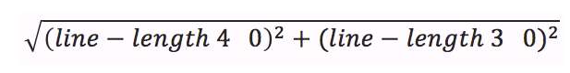

Convert the formula above into a Circle of Evaluation. (We've already gotten you started!)

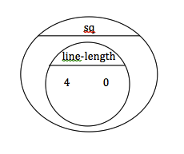

Convert the Circle of Evaluation into Racket code:

Design Recipe

Word Problem: distance

Write a function distance, which takes FOUR inputs:
- px: The x-coordinate of the player
- py: The y-coordinate of the player
- cx: The x-coordinate of another game character
- cy: The y-coordinate of another game character

It should return the distance between the two, using the Distance formula. (HINT: look at what you did on page 27!)

Contract+Purpose Statement

; __________________ : _________________________________________ -> ______________
name Domain Range

; _______________________________________________________________________________
What does the function do?

Give Examples

(EXAMPLE (___________________________________________)
Use the function here

_______________________________________________________________)
find another way to get the same result here

(EXAMPLE (___________________________________________)
Use the function here…

_______________________________________________________________)
find another way to get the same result here

Definition

(define (____________ ___________________)
function name variable names

________________________________________________)

Design Recipe

Word Problem: collide?

Write a function collide?,which takes FOUR inputs:
- px: The x-coordinate of the player
- py: The y-coordinate of the player
- cx: The x-coordinate of another game character
- cy: The y-coordinate of another game character
It should return true if the coordinates of the player are within 50 pixels of the
coordinates of the other character. Otherwise, false.

Contract+Purpose Statement

; __________________ : _________________________________________ -> ______________
name Domain Range

; _______________________________________________________________________________
What does the function do?

Give Examples

(EXAMPLE (___________________________________________)
Use the function here

_________________________________________________)
find another way to get the same result here

(EXAMPLE (___________________________________________)
Use the function here…

_________________________________________________)
find another way to get the same result here

Definition

(define (____________ ___________________)
function name variable names

________________________________________________)

Lesson 9

Catchy Intro:

Name, Age, Grade:

Game Title:

Back Story:

Characters:

Explain a piece of your code:

Presentation Feedback
For each question, circle the answer that fits best.

Was the introduction catchy? No way! A little. Definitely!

Did they talk about their characters? No way! A little. Definitely!

Did they explain the code well? No way! A little. Definitely!

Did they speak slowly enough? No way! A little. Definitely!

Did they speak loudly enough? No way! A little. Definitely!

Were they standing confidently? No way! A little. Definitely!

Did they make eye contact? No way! A little. Definitely!

Presentation Feedback
For each question, circle the answer that fits best.

Was the introduction catchy? No way! A little. Definitely!

Did they talk about their characters? No way! A little. Definitely!

Did they explain the code well? No way! A little. Definitely!

Did they speak slowly enough? No way! A little. Definitely!

Did they speak loudly enough? No way! A little. Definitely!

Were they standing confidently? No way! A little. Definitely!

Did they make eye contact? No way! A little. Definitely!

Design Recipe

Word Problem: red-shape

Write a function called red-shape, which takes in the name of a shape (“circle”, “triangle”, “star” or “rectangle”), and draws that shape. All shapes should be solid and red, and can be whatever size you choose

Contract+Purpose Statement

; __________________ : _________________________________________ -> ______________
name Domain Range

Give Examples
Write some examples of red-shape below. The first one has already been done for you.

(EXAMPLE (red-shape “circle” ) (circle 50 “solid” “red”) )
Use the function here What should the function produce?

(EXAMPLE (____________________________) ___________________________)
Use the function here What should the function produce?

(EXAMPLE (____________________________) ___________________________)
Use the function here What should the function produce?

(EXAMPLE (____________________________) ___________________________)
Use the function here What should the function produce?

Definition

(define (____________ ___________________)
function name variable names

(cond

(circle 50 “solid” “red”)
)

Translating into Algebra...

Values: Translate the Racket Code into Algebra
Racket Code | Algebra
(define x 10) | x = 10
(define y (* x 2)) | y = x*2
(define z (+ x y))
(define age 14)
(define months (* age 12))
(define days (* months 30))
(define hours (* days 24))
(define minutes (* hours 60))
Functions: Translate the Racket Code into Algebra
(define (double x)  (* x 2)) | double(x) = x*2
(define (area length width)  (* length width)) | area(length, width) = length * width
(define (circle-area radius)
(* pi (sq radius)))
(define (distance x1 y1 x2 y2)
(sqrt (+ (sq (- x1 x2))
(sq (- y1 y2))))

Design Recipe

Word Problem

A rocket is flying from Earth to Mars at 80 miles per second. Write a function that describes the distance D rocket train has traveled, as a function of time t

Contract+Purpose Statement
Every contract has three parts:

; ______D___________ : _________________________________________ -> ______________
name Domain Range

Give Examples
Write an example of your function for some sample inputs

D( 1 ) =
Use the function here What should the function produce?

D( 2 ) =
Use the function here What should the function produce?

D( ) =
Use the function here What should the function produce?

=
Use the function here What should the function produce?

Definition
Write the formula, giving variable names to all your input values.

D( ) =

Design Recipe

Word Problem

A rocket is traveling from Earth to Mars at 80 miles per second. Write a function that describes the time the rocket has been traveling, as a function of distance.

Contract+Purpose Statement
Every contract has three parts:

; __________________ : _________________________________________ -> ______________
name Domain Range

Give Examples
Write an example of your function for some sample inputs

=
Use the function here What should the function produce?

=
Use the function here What should the function produce?

=
Use the function here What should the function produce?

=
Use the function here What should the function produce?

Definition
Write the Formula, giving variable names to all your input values.

=

Design Recipe

Word Problem
A rocket leaves Earth, headed for Mars at 80 miles per second. At the exact same time, an asteroid leaves Mars traveling towards Earth, moving at 70 miles per second. If the distance from the Earth to Mars is 50,000,000 miles, how long will it take for them to meet?

Contract+Purpose Statement
Every contract has three parts:

; __________________ : _________________________________________ -> ______________
name Domain Range

Give Examples
Write an example of your function for some sample inputs

=
Use the function here What should the function produce?

=
Use the function here What should the function produce?

=
Use the function here What should the function produce?

=
Use the function here What should the function produce?

Definition
Write the Formula, giving variable names to all your input values.

=

Design Recipe

Word Problem

Contract+Purpose Statement
Every contract has three parts:

; __________________ : _________________________________________ -> ______________
name Domain Range

Give Examples
Write an example of your function for some sample inputs

=
Use the function here What should the function produce?

=
Use the function here What should the function produce?

=
Use the function here What should the function produce?

=
Use the function here What should the function produce?

Definition
Write the Formula, giving variable names to all your input values.

=

